Aggregate Functions

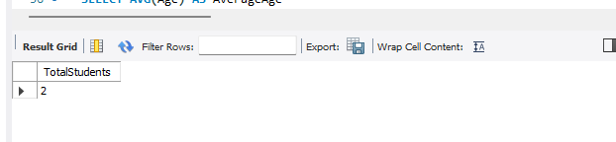

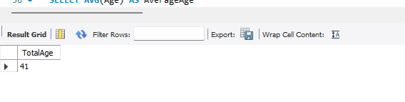

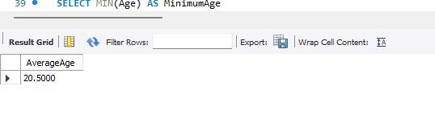

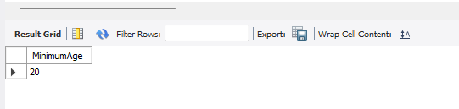
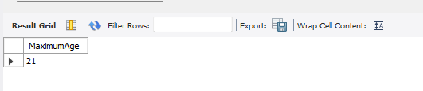

Explanation:
The queries calculate the total number of students, sum, average, minimum, and maximum age from the Students table.

